June 30, 2015 File #73
#150623-01
CUPE 4627

We are responding to your request for records “A copy of any correspondence from June 8, 2015 to June 23, 2015 provided to Peter Nunoda…..as a result of his solicitation for feedback……”

After a thorough search we have found no records responsive.

If you have any concerns regarding the processing of this request, you have 30 working days from the receipt of this letter to request a review by writing to:

Information and Privacy Commissioner
PO Box 9038, Stn Prov Govt
Victoria, British Columbia V8W 9A4
Tel. (250) 387-5629, Fax (250) 387-1696

If you request a review, please provide the Commissioner's office with a copy of this letter, a copy of your request for information and the reasons or grounds upon which you are requesting the review.

Yours truly,
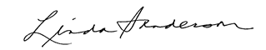
Executive Director
Human Resources
Vancouver Community College

Find out more at vcc.ca.

